Update of status of your present registration/date of validation has expired to upload the registration data in National Register for Homoeopathy-NCH (GoI) New Delhi.

S. No. & Registration Number | Name of Professional (IN BLOCK LETTERS) with recent photograph | Father’s name (IN BLOCK LETTERS)
1 | 2 | 3
01.  001-“A” | Dr. SHANU KOUL   | LATE. MAKHAN LAL KOUL
02.  003-“A” | Dr. ALTAF HUSSAIN KHAN  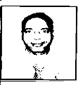 | SH. MOHD. AMIN KHAN
03.  004-“A” | Dr. DEEP GUPTA  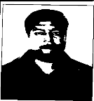 | SH. DEV RAJ GUPTA
04.  005-“A” | Dr. ARUN KUMAR  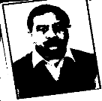 | LATE M.M. SINGH
05.  007-“A” | Dr. LONE MOHD. YAQOOB   | SH. GULL MOHD. LONE
06.  008-“A” | Dr. ANURADHA RANI | LATE SH.RAGHUNATH SAHAI

 | 
07.  009-“A” | Dr. VIJAYINDER SINGH JAMWAL  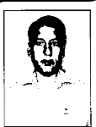 | LATE SH. KRISHAN SINGH
08.  012-“A” | Dr. ANAITULLAH AHMAD MIR  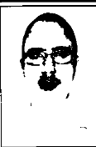 | SH.M.A.  MIR
09.  013-“A” | Dr. IRFAN AHMAD DHAR   | SH. MD. YOUSUF DAR
10.  014-“A” | Dr. SHOWKAT AHMAD BHAT   | SH. GULL MOHD. BHAT
11.  015-“A” | Dr. SINDU GUPTA  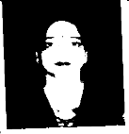 | SH. ASHOK GUPTA
12.  018-“A” | Dr. RIPUDAMAN MAHAJAN   | LATE SH. MANOHAR LAL MAHAJAN

13.  019-“A” | Dr. MONIKA SHARMA  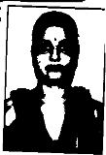 | SH. VISHNU DATT SHARMA
14.  020-“A” | Dr. SEEMA KAPOOR   | Sh. D.P KAPOOR
15.  021-“A” | Dr. GHULAM NABI WANI  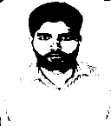 | SH. SONA ULLAH WANI
16.  022-“A” | Dr. NAVKIRAN KAPOOR   | SH. SATWANT SINGH
17.  024-“A” | Dr. FAROOZ AHMAD   | MOHD. SULTAN GULAM
18.  026-“A” | Dr. SANJAY RAINA  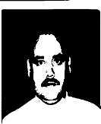 | SH. ROSHAN LAL RAINA
19.  028-“A” | Dr. AB. QAYOOM MIR | MOHD. AKBAR MIR

 | 
20.  029-“A” | Dr. MANZOOR AHMAD MAGRAY   | AB. KHALIQ MAGRAY
21.  030-“A” | Dr. NAHIDA WANI  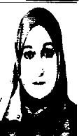 | SH. NOOR MOHD. WANI
22.  031-“A” | Dr. JAVEED IQBAL DAR   | SH. KHAZIR MOHD. DAR
23.  032-“A” | Dr. PAYAL CHOPRA   | SH. YOGESH CHOPRA
24.  033-“A” | Dr. LALIT SHARMA   | SH. GURDEV LAL SHARMA

25.  034-“A” | Dr. ANIL KUMAR DATTA   | SH. BRIJ-MOHAN DATTA
26.  035-“A” | Dr. VIKAS BACHLOO   | SH.  BHUSHAN BACHLOO
27.  036-“A” | Dr. SHAKTI DHAR SHARMA  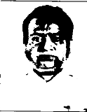 | SH. SHAM LAL SHARMA
28.  037-“A” | Dr. SHEEMA ISHRAT   | SH.ABDUL REHMAN
29.  038-“A” | Dr. TILAK RAJ SHARMA  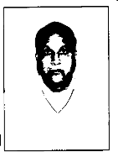 | SH.LAL CHAND SHARMA
30.  039-“A” | Dr. JYOTSNA MUKHI   | SH. VIJAY KUMAR MUKHI
31.  040-“A” | Dr. SURBHI GUPTA | SURESH CHANDER GUPTA

 | 
32.  041-“A” | Dr. SONIA KOUL   | LATE SH.  MAKHAN LAL KOUL
33.  042-“A” | Dr. DEEPTI GUPTA   | Dr.MADAN GOPAL GUPTA
34.  043-“A” | Dr. PAWAN KUMAR   | SH.GIRDI LAL SHARMA
35.  044-“A” | Dr. MAHESH CHANDER  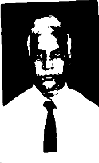 | LATE SH.INDER PARKASH
36.  045-“A” | Dr. GAGAN DEV   | SH.  KRISHAN KUMAR
37. | Dr.HILAL AHMED MANZOOR | SH.GH.MOHD.BHATT

046-“A” | 
38.  047-“A” | Dr.RAJ KUMAR ARORA   | SH. VED PARKASH
39.  049-“A” | Dr. RAMESHWAR KUMAR SHARMA   | SH.LAL CHAND SHARMA
40.  051-“A” | Dr.SHOWKAT AHMAD BHAT  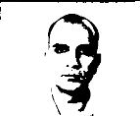 | SH.  GHULAM MOHI-DIN BHAT
41.  052-“A” | Dr.RAIES KHAN   | SH.ABDUL AHAD KHAN
42.  053-“A” | Dr.NAHEED ANSARI  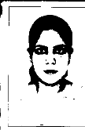 | SH.  SHABBIR AHMED ANSARI
43.  054-“A” | Dr. NITIN MAGOTRA   | SH. RAMESH SHARMA

44.  055-“A” | Dr. MUKESH KUMAR GUPTA  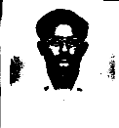 | SH.SATYA PAUL GUPTA
45.  056-“A” | Dr.HARJOT KAUR   | SH.S. BAKHSHISH SINGH
46.  057-“A” | Dr.MOHSIN MAQBOOL NAIK   | SH. MOHD.  MAQBOOL NAIK
47.  058-“A” | Dr.SHAH AYAZ MUDASIR YAQUB   | SH.MOHD.YAQUB SHAH
48.  059-“A” | Dr.SHEIKH MUKHTAR HUSSAN   | SH.  GHULAM HASSAN SHEIKH
49.  060-“A” | Dr.KEWAL KRISHAN SHARMA   | SH.JAGAT RAM SHARMA
50.  061-“A” | Dr. BASHIR AHMAD ITOO | SH. AB. KHALIQ ITOO

 | 
51.  062-“A” | Dr. MUZAFFAR AHMAD PARREY   | SH. GULL MOHD. PARREY
52.  063-“A” | Dr. TANVEER AHMED BHAT   | LT. SH. MOHD ISMAIL BHAT
53.  064-“A” | Dr. SHOWKAT AHMAD LONE   | KH. GHULAM HUSSAN LONE
54.  065-“A” | Dr. SURAYA AYAZ KACHROO   | SH. AYAZ AHMED KACHROO
55.  066-“A” | Dr. SUNITA KAUL   | SH. TEJ KRISHAN KAUL
56. | Dr. MUDASAR HAMID | SH. AB HAMID

067-“A” | 
57.  069-“A” | Dr. NAFHEEM-UL-AMEEN MOHARKEN  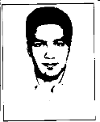 | SH. MOHD. AMEEN MOHARKEN
58.  070-“A” | Dr. SAT PAUL PANSOTRA   | SH. SADHU RAM PANSOTRA
59.  071-“A” | Dr. GH. MOHI-UD-DIN HAJAM   | SH. MOHD MAQBOOL HAJAM
60.  072-“A” | Dr. RADHIKA KOUL   | SH. AUTAR KRISHEN KOUL
61.  073-“A” | Dr. IRM MEHMOOD   | SH. GH. MOHD TELI
62.  074-“A” | Dr. BALJIT SINGH | SH. GURMUKH SINGH

 | 
63.  075-“A” | Dr. SHABIR AHMED DAR  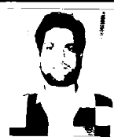 | SH. GH. MOHI-UD-DIN DAR
64.  076-“A” | Dr. HUMERA USTAD   | SH. NISAR AHMED
65.  077-“A” | Dr. AGARWAL ANSHUL  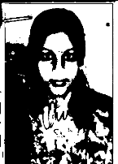 | AGARWAL MAHESH CHANDRA
66.  078-“A” | Dr. ASIFA SYED   | SH. MOHD SYED

67.  079-“A” | Dr. ROHINI SHARMA   | SH. HEM RAJ SHARMA
68.  080-“A” | Dr. MONALISA KAKROO   | SH. PIYARY LAL KAKROO
69.  081-“A” | Dr. FATIMABI SINGOTI   | SH. SHEIKH MUKHTAR HUSSAIN
70.  082-“A” | Dr. AJAY SINGH   | SH. BIDHEE SINGH
71.  083-“A” | Dr. ASHFAQ HUSSAIN SHAH   | SH. MOHD. HUSSAIN SHAH
72.  085-“A” | Dr. MEHNAZ RAFIQ   | SH. RAFIQ AHMAD BHAT

73.  086-“A” | Dr. TARIQ HUSSAIN PEERZDA  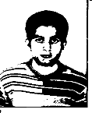 | PEER MOHD IBRAHIM
74.  087-“A” | Dr. ARTI BALDHOTRA  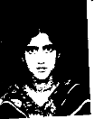 | SH. BODH RAJ BALDHOTRA
75.  088-“A” | Dr. MARINALINI BAKSHI   | SH. BRIJENDER BAKSHI
76.  089-“A” | Dr. SHEFALI SHARMA  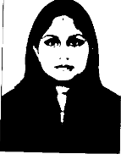 | SH. SK. SHARMA
77.  090-“A” | Dr. MEENAKSHI   | SH. R.S DALPATIA
78.  091-“A” | Dr. LOVELEENA GUPTA  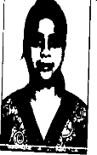 | SH. VINOOD GUPTA

79.  092-“A” | Dr. REETIKA   | SH. RAVI KUMAR
80.  094-“A” | Dr. TABASUM RASHID BAZAZ   | SH. ABDUL RASHID BAIAI
81.  095-“A” | Dr. RIYAZ AHMAD BHAT   | GH. NABI BHAT
82.  096-“A” | Dr. SYED UBAID MUHAMAD   | SH. SYED MOHD SHAFI GOWHER
83.  097-“A” | Dr. RAHINA AKHTER   | SH. GH. NABI BHAT
84.  098-“A” | Dr. KHALIDA AKHTER   | SH. BASHIR AHMAD NENGROO
85.  099-“A” | Dr. MUNEZZA IQBAL | SH. MOHD IQBAL

 | 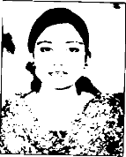
86.  100-“A” | Dr. MADIHA ARJUMAND SEIKH  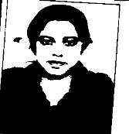 | SH. MUKHTER AHMED
87.  102-“A” | Dr. NITIKA Sharma  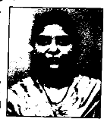 | SH. RAMESH SHARMA
88.  103-“A” | Dr. ANJUM ARA SIDDIQUI  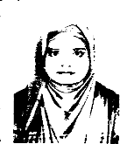 | SH. SAJAD AHMAD PANDIT
89.  104-“A” | Dr.ISHITA GANJOO  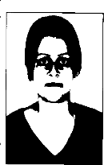 | SH. RAJINDER KUMAR GANJOO
90.  105-“A” | Dr.NEERAJ KUMAR GUPTA   | SH. ROMESH KUMAR
91.  106-“A” | Dr. SADIA KOUSER | SH. ZUBAIR AHMED

 | 
92.  108-“A” | Dr. SHOWKAT AHMAD MIR  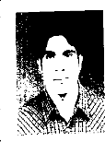 | SH. ABDUL GAFFAR MIR
93.  109-“A” | Dr. RUBINA BASHIR   | SH. BASHIR AHMAD BHAT
94.  110-“A” | Dr. NAZNEEN DAR  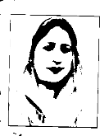 | SH. MUSHTAQ AHMED DAR
95.  111-“A” | Dr. RABIA KOUSAR   | SH.  MEHMOOD AHMAD KHAN
96.  114-“A” | Dr. TANVEER IQBAL   | SH. MOHD. ARIF
97.  115-“A” | Dr. GULNAZ BEGUM | SH. NAZIR HUSSIAN

 | 
98.  119-“A” | Dr. SHALLU RAZDAN   | SH. SHARWAN RAZDAN
99.  120-“A” | Dr. SWAMI RAJ BHAGAT   | SH. TEJ RAM BHAGAT
100.  121-“A” | Dr. SOHAIL AHMAD WANI  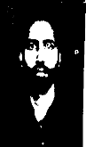 | SH. MOHD. AMIN WANI
101.  123-“A” | Dr. MEENAKSHI CHIB  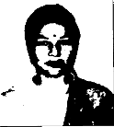 | SH. KULWANT SINGH
102.  124-“A” | Dr. IFRAH DIL NAWAZ   | SH. SHAH NAWAZ SHEIKH
103.  125-“A” | Dr. SUPRIYA BAZAZ | SH. DILEEP KUMAR BAZAZ

 | 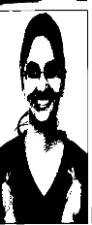
104.  127-“A” | Dr. JYOTI JALOTRA  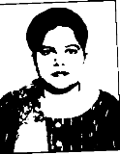 | SH. KANWAL JIT JALOTRA
105.  128-“A” | Dr. FOZIA KALSOOM   | SH. MOHD. AFZAL
106.  130-“A” | Dr. MUZAMMIL NASEEN   | SH.MOHD. NASEEM SHAH
107.  131-“A” | Dr. IRFAN AHMAD BEIGH   | SH. NAZIR AHMAD BEIGH
108.  132-“A” | Dr. MOHD. ASLAM  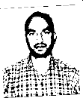 | SH. FAZAL-UR-REHMAN
109.  134-“A” | Dr. SUKRITI SHARMA  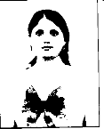 | SH. TUSHAR KANTI SHARMA

110.  135-“A” | Dr. BHAVANA ARORA   | SH. BALDEV RAJ ARORA
111.  136-“A” | Dr. MIAN ARSHAD AHMED   | SH. GHULAM RASOOL
112.  137-“A” | Dr. SANJEEV KUMAR   | SH. CHUNI LAL
113.  138-“A” | Dr. MEHNAAZ BASHIR   | SH. QAZI BASHIR AHMAD
114.  139-“A” | Dr. SYED MOHD. ABID SHAH  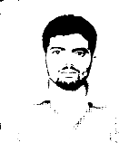 | SH. AB. RASHID SHAH
115.  140-“A” | Dr. PEER MUZAMIL ZAHOOR   | SH. PEER MOHD. ZAHOOR
116.  141-“A” | Dr. PREETI BHAGAT | SH. DUNI CHAND BHATTI

 | 
117.  142-“A” | Dr. MEENU BALDHOTRA   | SH. BODH RAJ BALDHOTRA
118.  143-“A” | Dr. RADHIKA BHARTI  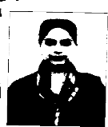 | SH. RATTAN LAL
119.  144-“A” | Dr. SHARAZ AHMED   | SH. NAZIR HUSSAIN
120.  145-“A” | Dr. SAHIL GUPTA   | SH. SHAM LAL GUPTA
121.  146-“A” | Dr. DEEPIKA BHARTI  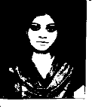 | SH. MANOHAR LAL
122.  147-“A” | Dr. ARSHED IQBAL MALIK | SH. MOHD. YAQOOB MALIK

 | 
123.  148-“A” | Dr. TITENDERPAL SINGH  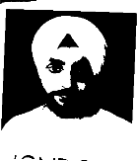 | SH. SURAJ SINGH BALI
124.  149-“A” | Dr. PEER NASEERUL HASHIM   | SH. SANA ULLAH PEER
125.  150-“A” | Dr. SOFIYA ASHRAF  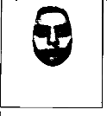 | SH. MOHD. ASHRAF SHAH
126.  151-“A” | Dr. IRUM KHATOON  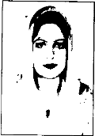 | AFTAB AHMED MALIK
127.  152-“A” | Dr. RUBIYA MUSHTAQ   | SH. MUSHTAQ HUSSAIN SHAH
128.  153-“A” | Dr. VASUDHA VIJ   | SH. RAMAN KUMAR VIJ

129.  155-“A” | Dr. SADDIF FATIMA  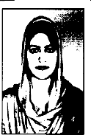 | SH. AFTAB AHMED MALIK
130.  158-“A” | Dr. KUMARI SHAVETA  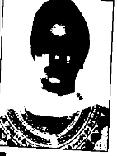 | SH. RASHPAL SINGH
131.  162-“A” | Dr. TEJINDER SANDHU   | SH. KRISHAN LAL
132.  164-“A” | Dr. IRFAN GUL WANI   | SH. GHULAM MOHD. WANI
133.  165-“A” | Dr. NEHA KOHLI   | SH. RAKESH KHOLI
134.  166-“A” | Dr. SHAHNAWAG PARWAZ | SH. MOHD. HANIEF

 | 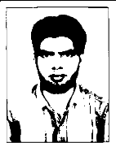
135.  167-“A” | Dr. MODH. ARFAZ  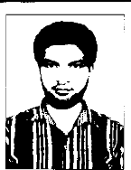 | SH. MOHD. ISHAQ
136.  168-“A” | Dr. UMAR MUKHTAR   | SH. MUKHTAR HUSSAIN
137.  170-“A” | Dr. SANIA SHEIKH   | SH. BASHIR HUSSAIN SHEIKH
138.  175-“A” | Dr. VISHAL CHOUDHARY   | SH. MOHINDER LAL CHOUDHARY
139.  176-“A” | Dr. AUDIL RASHID   | SH. AB. RASHID SHAN
140.  178-“A” | Dr. AISHWARYA WAZIR | SH. RAJINDER WAZIR

 | 
141.  179-“A” | Dr. SUNAILLA RAINA   | SH. RAMESH CHANDER RAINA
142.  184-“A” | Dr. YASIR SHAFI   | SH. MOHD. SHAFI BAZDAR
143.  185-“A” | Dr.ASMA GUL SHAH   | SH. GHULAM MOHAMAD SHAH
144.  189-“A” | Dr.ATYA AZAM  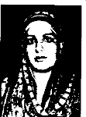 | SH. MOHD. AZAM
145.  192-“A” | Dr. SHERAZUL HASSAN   | SH. GH. HASSAN
146.  193-“A” | Dr. SABINA HASAN | SH.  MANSOOR HASAN

 | 
147.  195-“A” | Dr. URMILA KOUL   | SH. RAJESH KOUL
148.  198-“A” | Dr. NEETU RAINA   | SH.  DWARKA NATH RAINA
149.  203-“A” | Dr. MOHD. ASIF  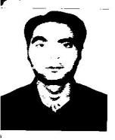 | SH. ABDUL GHANI
150.  205-“A” | Dr. NAVNEET PAL KOUR  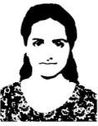 | SH. HARCHARAN PAL SINGH
151.  212-“A” | Dr. MIR ABID BASHIR   | SH. BASHIR AHMAD MIR
152.  213-“A” | Dr. BUSHRA ASHRAF SHAH | SH. MOHD. ASHRAF SHAH

 | 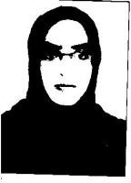
153.  218-“A” | Dr. SHAREEFABI KHAN  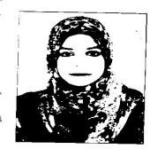 | SH. ARSHAD IQBAL MALIK
154.  220-“A” | Dr. MANVEEN KOUR  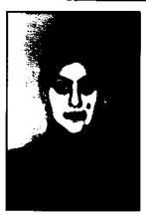 | SH. MATINDER SINGH
155.  221-“A” | Dr. MUBASHRA ZEENAT   | SH. NAZIR AHMED KHAN
156.  222-“A” | Dr. SHAHANA KHAN   | SH. KHRSHEED KHAN
157.  224-“A” | Dr. FRIFTA JANBAZ   | SH. JANBAZ KHAN

158.  227-“A” | Dr. CHANDER MOHAN   | SH. DUNI CHAND
159.  230-“A” | Dr. SALEEM-UR-REHMAN  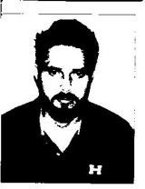 | SH. ABDUL REHMAN
160.  231-“A” | Dr. MANSOOR AHMAD MALIK   | SH. ZAHOOR AHMAD MALIK
161.  232-“A” | Dr. ASHRAF  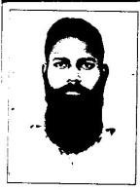 | SH. BILLA
162.  238-“A” | Dr. SHALINI ALEY   | SH. JEET BALADUR ALEY
163.  240-“A” | Dr. AAMIR AHMAD MALIK   | SH. MOHD. RAMZAN MALIK

164.  241-“A” | Dr. CHAHAT GUPTA   | SH. KRANTI GUPTA
165.  242-“A” | Dr. HARJINDER KAUR  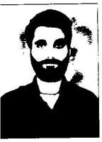 | SH. DALIP SINGH
166.  243-“A” | Dr. MOHD. SLEEM  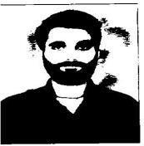 | ALTAF HUSSAIN
167.  244-“A” | Dr. AMITA HARNAL   | SH. PARSHOTAM SINGH
168.  245-“A” | Dr. IMTIAZ HUSSAIN  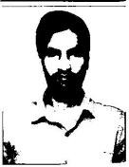 | SH. MOHD. YOUSUF PARRAY
169.  246-“A” | Dr. SURBHI GANDOTRA | SH. ROMESH GANDOTRA

 | 
170.  247-“A” | Dr. SUMMRA IMTIAZ  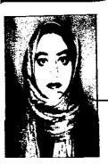 | SH. IMTIAZ AHMED
171.  249-“A” | Dr. AHSAN BASIT BHATTI   | SH. ABDUL BASIT
172.  250-“A” | Dr. YASHI PADHA   | SH. KAUSHAL KUMAR PADHA
173.  251-“A” | Dr. ANJUM SHAHEEN NAZ  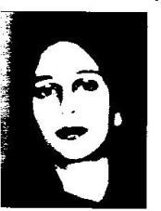 | SH. MOHD. AFZAL
174.  253-“A” | Dr. JAN SHER KHAN   | SH.MOHD. ALAM
175.  256-“A” | Dr. GOUSIA TANEEM | SH. TARIQ HUSSAIN

 | 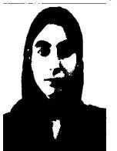
176.  257-“A” | Dr. TANVI RAJPUT   | SH. ANU PAWAN SINGH
177.  259-“A” | Dr. NAZIA TANVEER   | SH. MANAWAR AHMED
178.  261-“A” | Dr. HARISH PARTAP SINGH  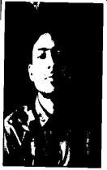 | SH. KULWANT SINGH CHIB
179.  263-“A” | Dr. RUMMAN ZURAR   | SH. ZURAR MOHD. DHAR
180.  268-“A” | Dr. SADAM HAMID   | SH. ABDUL HAMID

181.  270-“A” | Dr. BORKAR PREETI DEODAS   | SH. DEODAS BORKAR
182.  271-“A” | Dr. PRIYANKA TIKU   | SH. RAJINDER TIKU
183.  273-“A” | Dr. PRIYANKA KUMARI  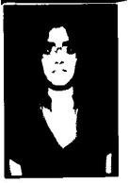 | SH. ASHOK KUMAR
184.  274-“A” | Dr. BABNEET KOUR  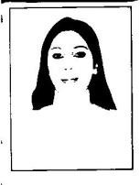 | SH. SATINDER SINGH
185.  275-“A” | Dr. RUHTANJALI CHALOTRA   | SH. MANOJ KUMAR CHALOTRA
186.  277-“A” | Dr.HALEEMA RAZWANA  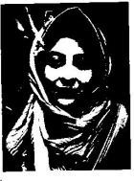 | SH. MOHD. RAFIQ

187.  278-“A” | Dr. MOHD. MAHTAB   | SH. MOHD. AZIZ
188.  279-“A” | Dr. ANAM RAZA   | SH. SHAMIM RAZA
189.  280-“A” | Dr. MOHD. KABIR   | SH. ABDUL MAJID
190.  281-“A” | Dr. CHOWDHARY NISAR AHMED   | SH. MAQBOOL AHMED
191.  282-“A” | Dr. ANISH SHARMA  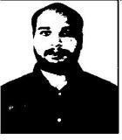 | SH. KAMALKL KISHORE SHARMA
192.  285-“A” | Dr. SYED SALEEN SHOWKAT   | SH. SYED SHOWKAT HUSSAIN
193.  286-“A” | Dr. SHIVANI BHAGAT | SH. YASHPAL BHAGAT

 | 
194.  290-“A” | Dr. IRFAN RAHID WANIE   | SH. ABDUL RASHID WANIE
195.  291-“A” | Dr. ANJUM UL NISA  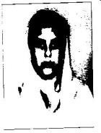 | SH. HAQ NAWAZ
196.  292-“A” | Dr. SARISH ZABAIR   | SH. MOHD. ZABIR
197.  293-“A” | Dr. FAIZAN YONUS   | SH. MOHD. YOUNUS AKHOON
198.  294-“A” | Dr. PARUL MENGI   | SH. AJAY MENGI
199.  295-“A” | Dr. AAIMAN NIZAR   | SH. NISAR AHAMAD GANIE

200.  297-“A” | Dr. NAHIDA AKHTAR   | SH. ABDUL LATIF
201.  298-“A” | Dr. NAZRA MALIK  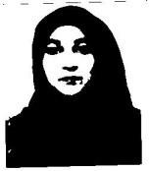 | SH. MOHD. ISHAQ MALIK
202.  299-“A” | Dr. SUHAIL YAQOOB   | SH. MOHD. YAQOOB SHAN
203.  301-“A” | Dr. BURJISH AYUB  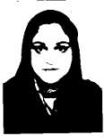 | SH. MOHD. AYUB DAR
204.  304-“A” | Dr. MINAKSHI DEVI   | SH. RAJINDER KUMAR

